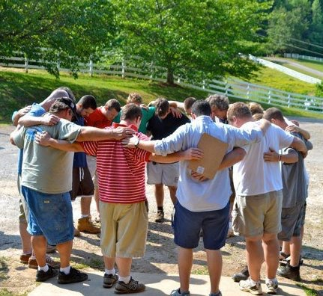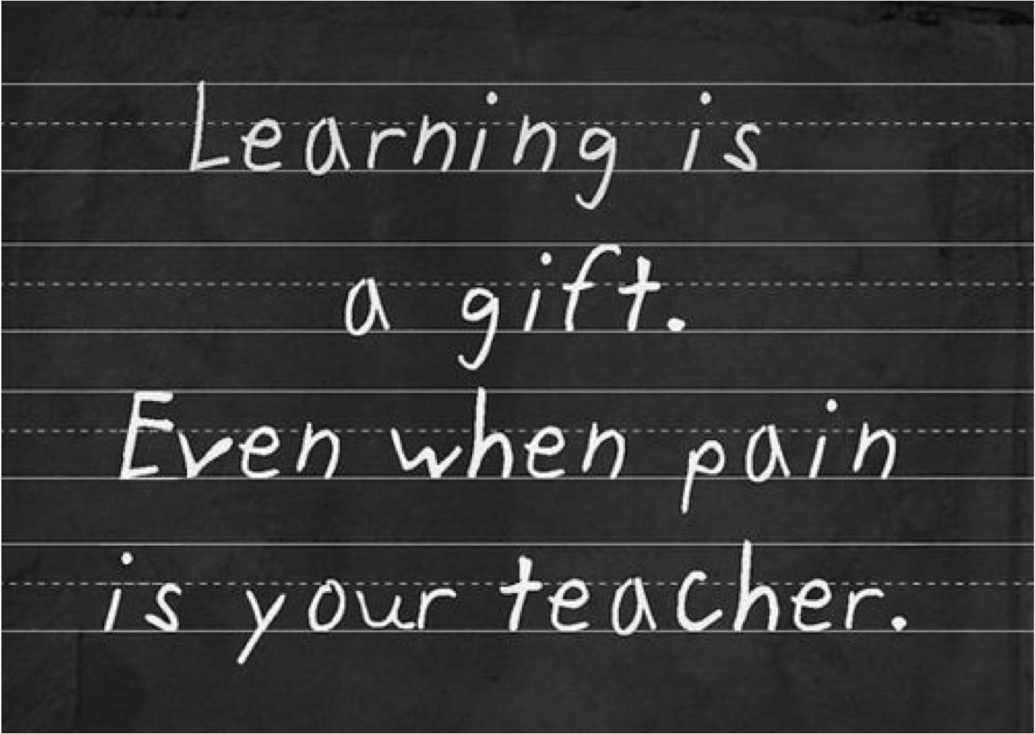

REGENERATION CENTER

TURNING THE HEARTS OF THE FATHERS TO THEIR CHILDREN, AND THE HEARTS OF THE CHILDREN TO THEIR FATHERS.. MALACHI 4:6

# TH

# The Jericho House is a Christ-Centered drug & alcohol recovery program located in Cleveland, Ga. The Jericho House ministers healing and restoration to men caught in addiction. Using biblical counseling, teaching, small groups and work programs. We provide men with a safe and spiritually sound environment to bring about a whole lifestyle change. We truly believe that the only way to break the cycle of addiction in a life, a family, and a community is through the miracle-working power of Jesus Christ, and with the presence of the Holy Spirit.

At the Jericho House the goal is to address the whole person (spirit, soul and body). "So, in addition to spiritual counseling, the Jericho House will partner with other qualified medical and mental health professionals to thoroughly address additional personal needs."

The Jericho House is supported by:

1. Prayers
2. Donations
3. Industries (Furniture Shop, JH Services - Lawn-care & Handy-man services)
4. Annual Events (Golf Tournament & Pancake Breakfast)
5. The Regeneration Program

The Jericho House is a Georgia Based 501(c)3 non-profit ministry. All funds raised from donations, events, & gifts are used to operate and continue the mission of walking with men and their families from “DETOX TO THEIR DIPLOMA”

The Jericho House

P.O. Box 2863

Cleveland, GA 30528

706-878-0015

[www.thejerichohouse.org](http://www.thejerichohouse.org)

**There is hope**

**on the**

**Road to Recovery**

FOR HELP TODAY CALL 706-878-0015

| We provide Counseling for the three basic needs for mankind. | | |
| --- | --- | --- |
| **Physical** | **Emotional** | **Spiritual** |
| Chemical Detox | Safe resolution to past hurts | Tools to begin a new life |
| Supervised Chemical detox | Confidential Individual and group counseling | Truth vs. Lies |
| Physical Exercise/Diet | Building Bridges to Broken Relationships | New Life |
| Work Ethic | Conflict management | Spiritual Disciplines |

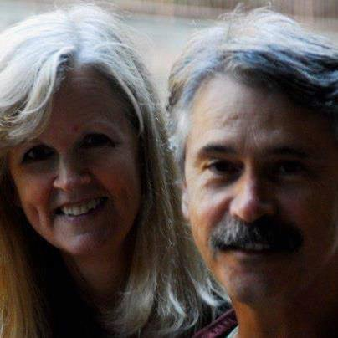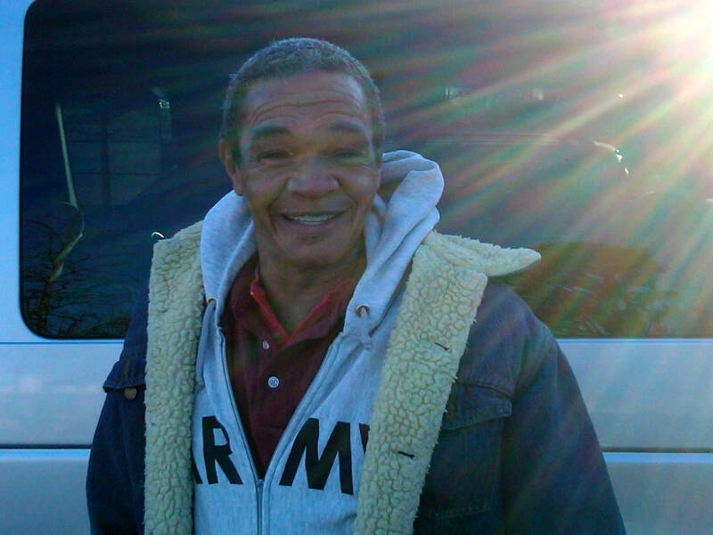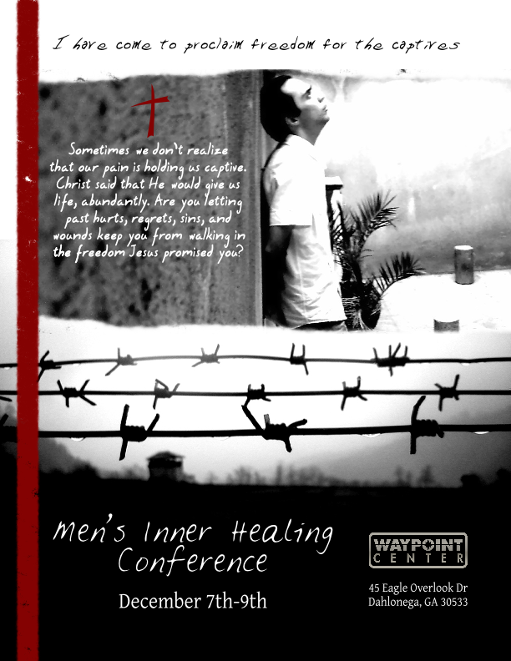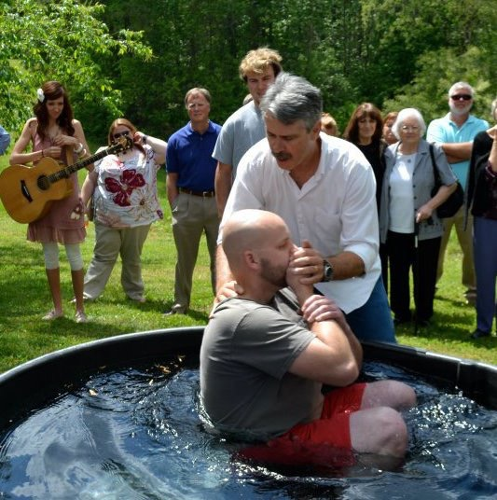

At The Jericho House our mission is to become a refuge for men caught in addictions and to help them and their families experience personal healing and restored relationships through salvation in Jesus Christ and the power of the Holy Spirit.

***It is for freedom that Christ has set us free. Stand firm, then, and do not let yourselves be burdened again by a yoke of slavery* GALATIONS 5:1**

# From Tragedy to Testimony

**"My addiction left me with little hope for the future. I had broken or destroyed many relationships and now have hope of rebuilding and growing those relationships. The Jericho House has given me the tools, guidance and vision for how to live my life going forward."**

**"My family and work life were a mess. I was losing touch with reality, and the care and love of those close to me.  My ability to continue my job at a high level was reaching a critical point and was headed the wrong way. Larry and the staff at The Jericho House provided me the opportunity for a regeneration process which helps to renew my mind and nurture my physical well-being. In turn, I can now begin to repair those relationships  strained by my addiction.**

  How Can You Help?

**HELP A MAN! YOU HELP A FAMILY!**

Help a man, you help a family. Help a family you help a community. Help a community you help a country…and the world.

The taproot of healing begins with the fathers. The last verse in the Old Testament states this fact:

*“He will turn the hearts of the fathers to their children, and the hearts of the children to their fathers…”* **Malachi 4:6**

By sponsoring a man in the 12-month regeneration program, you, your church or your company can be a part of God’s miracle of turning the hardened stone heart’s of chemically addicted men to softened compassionate hearts that genuinely care for their loved ones and significant others in their lives.

The root problem is not that the addicted man has a “drinking and drugging” problem. The essence of addiction is a “living problem”. Chemically dependent men cannot live life on life’s terms. You can make a difference in helping promote an environment where the power of the Holy Spirit transforms seemingly hopeless men into the fathers God created them to be – empowering men to succeed in life with dignity, peace and freedom.

It costs The Jericho House $21,000.00 to put one man through an entire 12-month regeneration curriculum. We only ask that the man pay us $9,600.00 for the entire year. At The Jericho House, we are well aware of the financial destitution that accompanies the addiction, and it’s our principle never to turn away a broken man because he has no way of paying for his treatment.

If you, your church or company chooses to sponsor a man for $9,600.00, your donation helps pay for that man’s room-n-board, food for the entire year, our regeneration textbooks and classroom journals. In short, your donation is contributing to a man’s chance at a new life.

And when you help a man, you help a family. When you help a family, you help a community. Help a community…you’re helping the world. At the Jericho House we begin the revolutionary healing of the entire communities with the fathers of today and tomorrow – in Jesus’ name. And we would be blessed to have you, your church or company helping us help others.

Larry McKenna and his family

Founders/Executive Director